 | BEECHER FIRE PROTECTION  DISTRICT  Sign Up for Smart911  Free emergency alerts & a safety profile that helps first responders protect you | 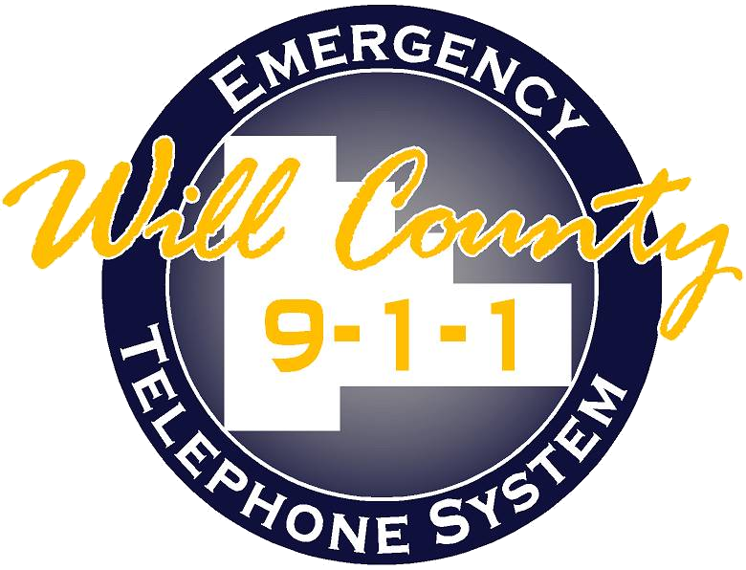

Smart911 lets Will County 9-1-1 send you alerts about severe weather, road closures, missing persons and evacuations — by text, call, email or app. It also lets you build a private Safety Profile that appears on the dispatcher’s screen the moment you call 9-1-1. 100% Free • Takes 5–10 minutes

HOW TO SIGN UP  - Scan the QR code or visit the website. Point your phone camera at the QR code, or go to the sign-up link. Then tap Sign Up Today.  - Create your account. Enter your name and email, create a password, then select Create Account.  - Add & confirm your address. Type your home address and click Continue. Use the map to drop the pin in the right spot, then Confirm this Address.  - Verify your phone number. Add your phone(s) and confirm by text message or automated call so your profile reaches 9-1-1.  - Complete your Safety Profile. Add household members, medical details, pets, vehicles and emergency contacts — as much or as little as you like.  - Turn on alerts & save. Under Preferences, opt in to Will County alerts, pick text / voice / email, and Save. You’re done!  - If you need assistance with signing up for Smart911 please contact Beecher Fire Protection District Assistant Chief Tim McGannon at (708) 497-0445 or at tmcgannon@beecherfire.org | WHAT YOU CAN ADD TO YOUR PROFILE  - Household members  - Medical info & allergies  - Pets  - Vehicles  - Emergency contacts  - Extra addresses  GOOD TO KNOW  - Always state your location when you call 9-1-1.  - The Smart911 app is free on the App Store & Google Play.  - Your info is private & only seen by 9-1-1 when you call.
  Especially important for households with: seniors, young children, or anyone with medical conditions, disabilities or mobility needs. You can also build a profile on behalf of a loved one and list yourself as their contact.
  SCAN TO SIGN UP
  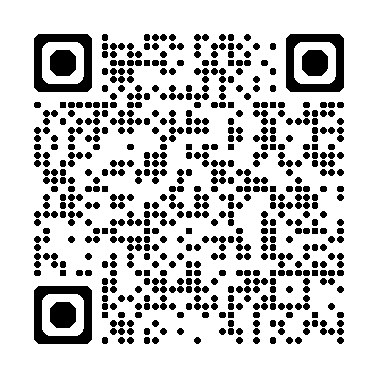
  Open your phone’s camera and point it at the code above.
  smart911.com › Will County IL
Questions or need help? Email rave@willcounty911.gov  Will County 9-1-1 • (815) 725-1911 • willcounty911.gov/smart-911 |  | SIGN UP- IT’S FREE

