Foreign Fire Insurance Advisory Board

Monday, November 2nd, 2020
Temporary Fire Station located
Across from 711 Penfield
8:30AM

The Beecher Foreign Fire Insurance Advisory Board will conduct a regular meeting on Monday, November 2, 2020 at 8:30am in the temporary fire station located across from 711 Penfield St, Beecher, Illinois 60401, for the purpose set forth in the following addenda:

ORDER OF BUSINESS
- CALL TO ORDER
- ROLL CALL
- APPOINTMENT OF OFFICERS
- NEW BUSINESS
1. Budget Overview
- NEXT REGULAR MEETING –
TBD
G. ADJOURNMENT- ______, ______ @________AM

To be Determined
Secretary, FFIAB
10/30/2020
01:00PM
AJK

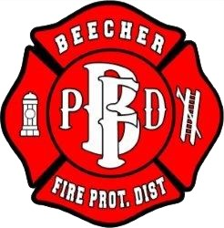

Members

Chief Joe Falaschetti
Lieutenant David Conrad
FF/PM Carm Welsh
FF/PM Joseph Spanier
FF/EMT Austin Behrens

